**PRISON MANAGEMENT SYSTEM**

**Q1. Write necessary queries to register new user/ person.**

* Insert Prisoner Details

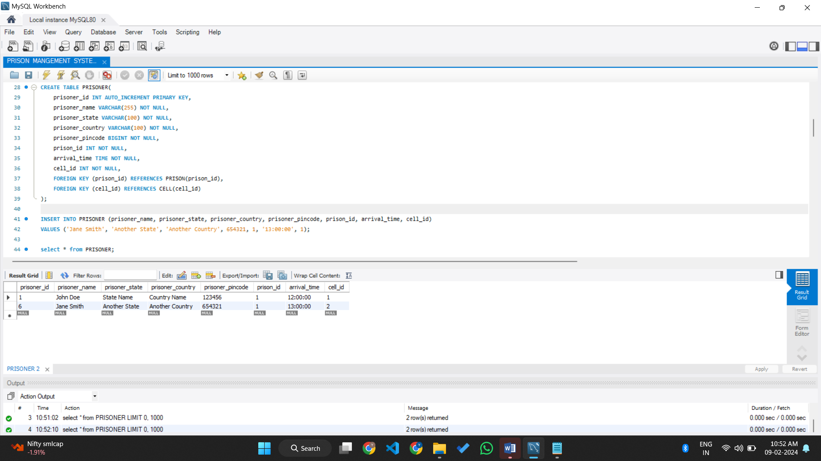

**Q2. Write necessary queries to add to the list of diagnosis of the prisoners tagged by date.**

* Insert Prisoner Diagnosis Details

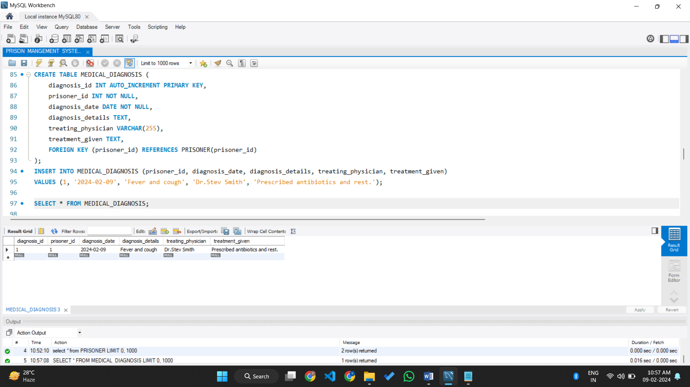

**Q3. Write necessary queries to fetch required details of a particular Prisoner.**

* Fetched Prisoner Details Using **prisoner_id**

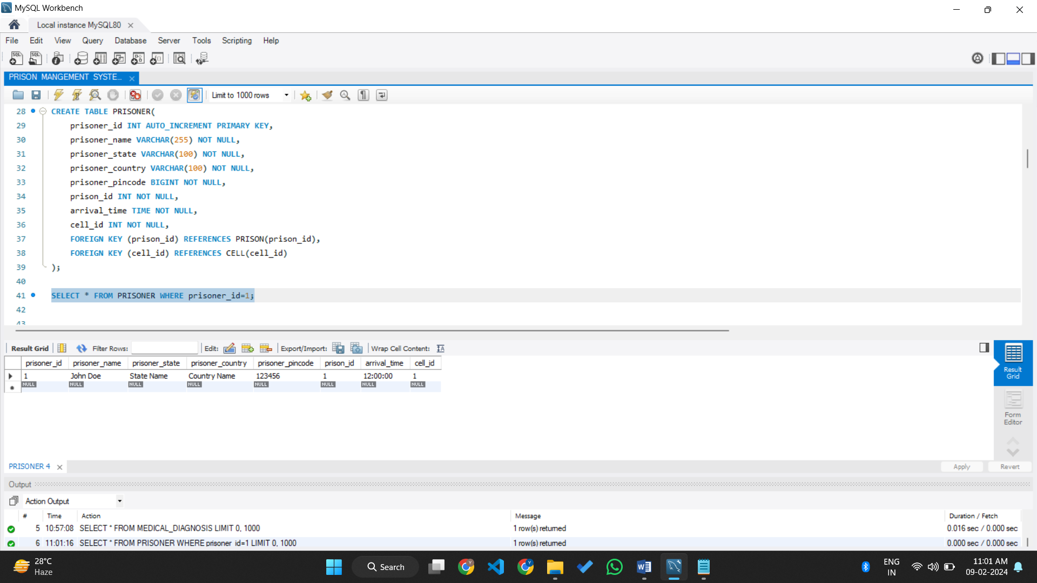

**Q4. Write necessary queries to prepare bill for the patient at the end of checkout.**

* In Context of Prison Management System, I’ have create a stored procedure to calculate the visiting charges of the prisoners.

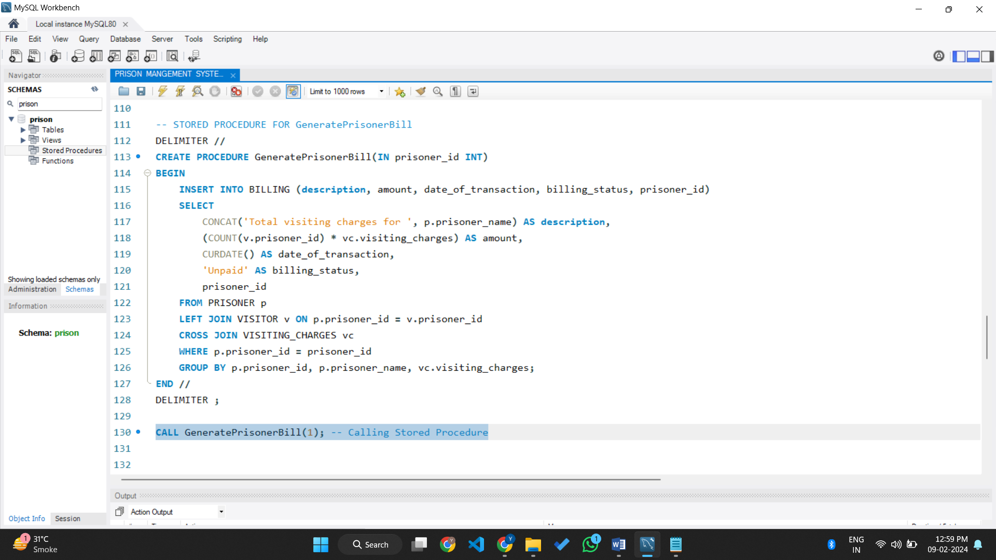

**Q5. Write necessary queries to fetch and show data from various related tables (Joins)**

* Create a join which can show prisoner name and id from PRISONER table and their cell_no from CELL table

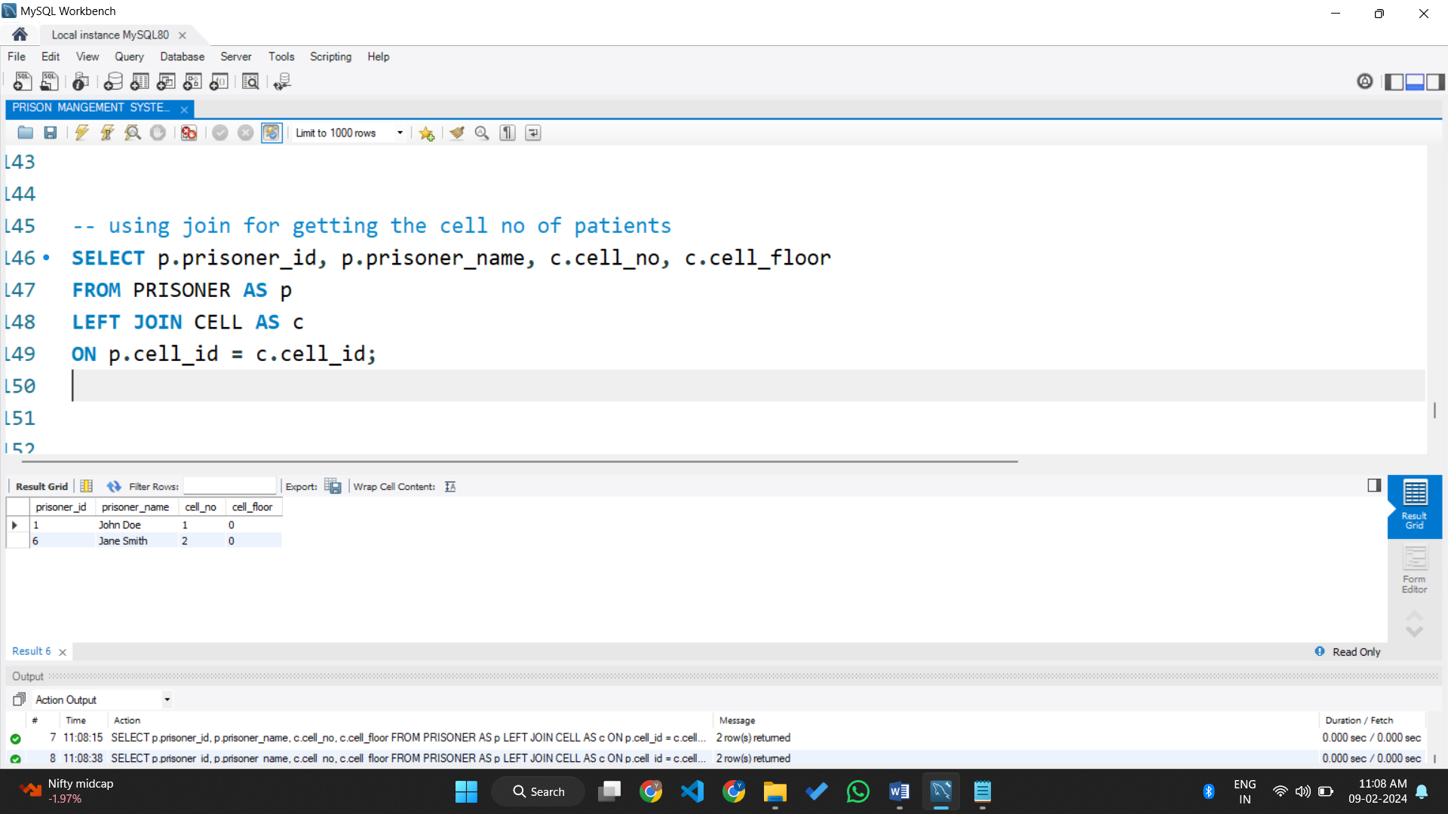

**Q6. Optimize repeated read operations using views/materialized views.**

* Make use of VIEW for getting patient name and their diagnosis details

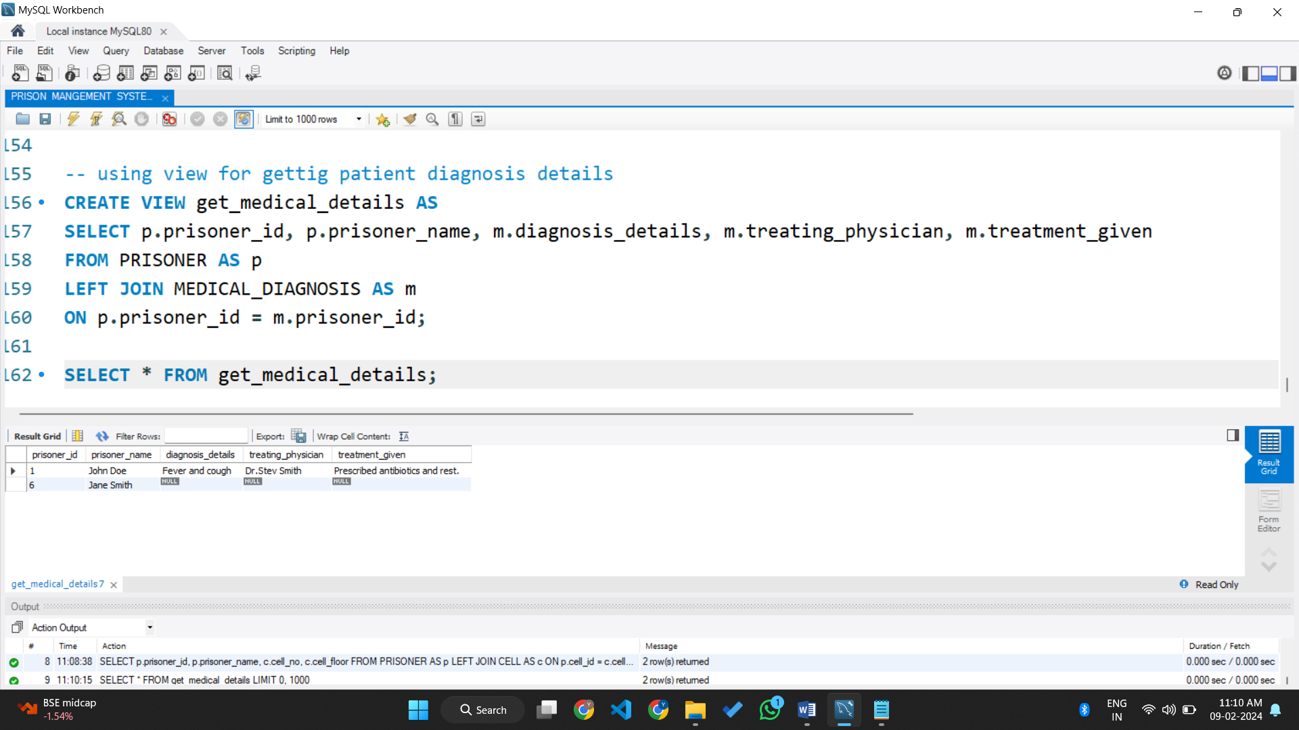

**Q7. Optimize read operations using indexing wherever required.**

* Create index on prisoner_name column.

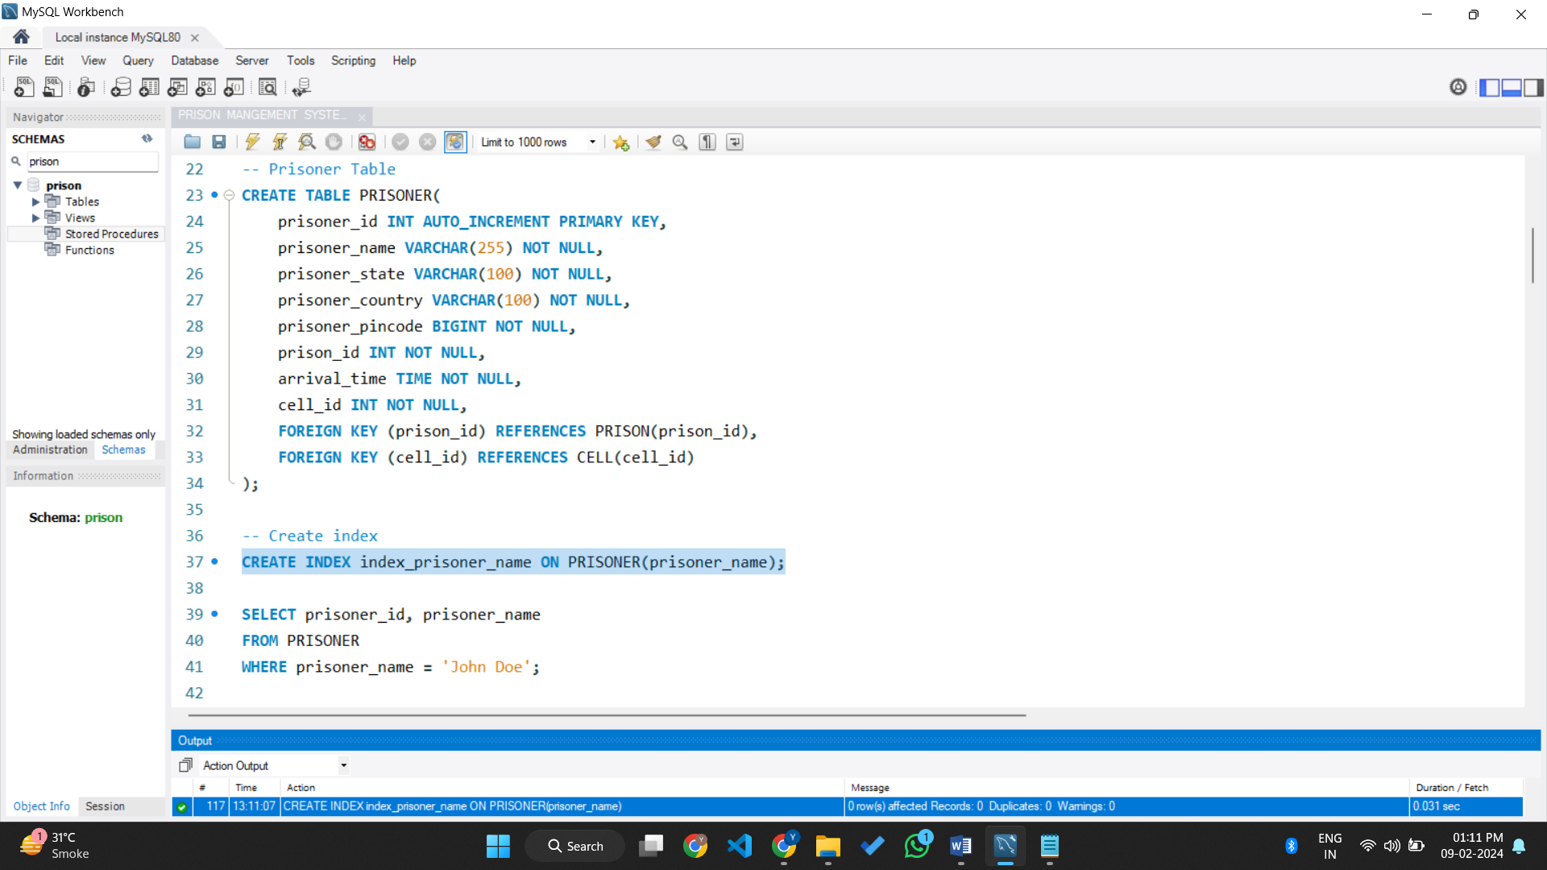

**Q8. Try optimizing bill generation using stored procedures.**

Here, I’ have Generate bill based on Visitor and charges of Visit.

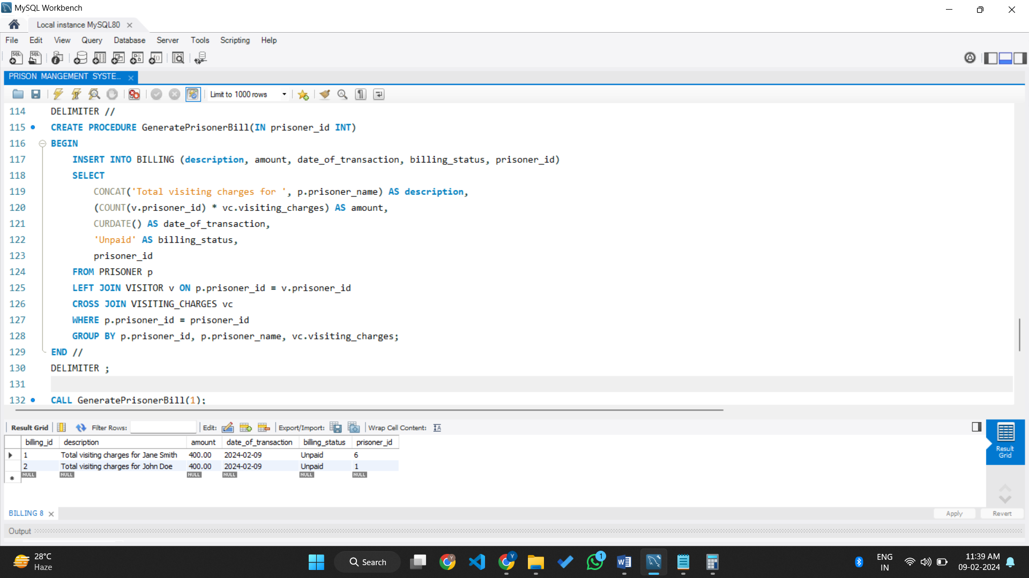

**Q9. Add necessary triggers to indicate when patients medical insurance limit has expired.**

* In Context of Prison Management System, I’ have created trigger whe­­n prisoner has been Release the trigger will be called(triggered).

